**Create table**

create table bank

(

bank id int primary key,

name varchar(30),

address varchar(30)

);

create table branch

(

branch_id int primary key,

bank_id int references bank(bank_id) on delete cascade,

address varchar(30)

);

create table customer

(

client_id int primary key,

name varchar(30),

surname varchar(30),

branch_id int references branch(branch_id) on delete cascade,

age int

);

create table account2

(

account_no int primary key,

balance varchar(20),

opendate varchar(30),

status varchar(30),

client_id int references customer(client_id)

);

create table worker

(

worker_id int primary key,

name varchar(30),

surname varchar(30),

branch_id int references branch(branch_id) on delete cascade

);

**Insertion values**

insert into bank values(1,'canara bank','bangalore');

insert into bank values(2,'sbi','mangalore');

insert into bank values(3,'hdfc','tumkur');

insert into bank values(4,'baroda','sira');

insert into bank values(5,'karanataka bank','belgavi');

insert into branch values(10,1,'chitradurga');

insert into branch values(11,2,'Dvg');

insert into branch values(12,3,'kolar');

insert into branch values(13,4,'dabaspete');

insert into branch values(14,5,'mg road');

insert into customer values(1234,'akashy','r',10,20);

insert into customer values(6789,'akash','v',11,21);

insert into customer values(4567,'varun','kumar',12,23);

insert into customer values(6767,'arun','kumar',13,26);

insert into customer values(5678,'guru','rd',14,28);

insert into account2 values(400,'1000','12-6-2009','active',1234);

insert into account2 values(401,'2000','13-4-2009','active',6789);

insert into account2 values(402,'3000','6-6-2014','active',4567);

insert into account2 values(403,'3300','7-9-2010','deactive',6767);

insert into account2 values(404,'3500','9-9-2008','deactive',5678);

insert into worker values(71,'santosh','kumar',10);

insert into worker values(72,'bhuvan','rathod',11);

insert into worker values(73,'mohith','na',12);

insert into worker values(74,'javeed','mohammed',13);

insert into worker values(75,'asha','kumari',14);

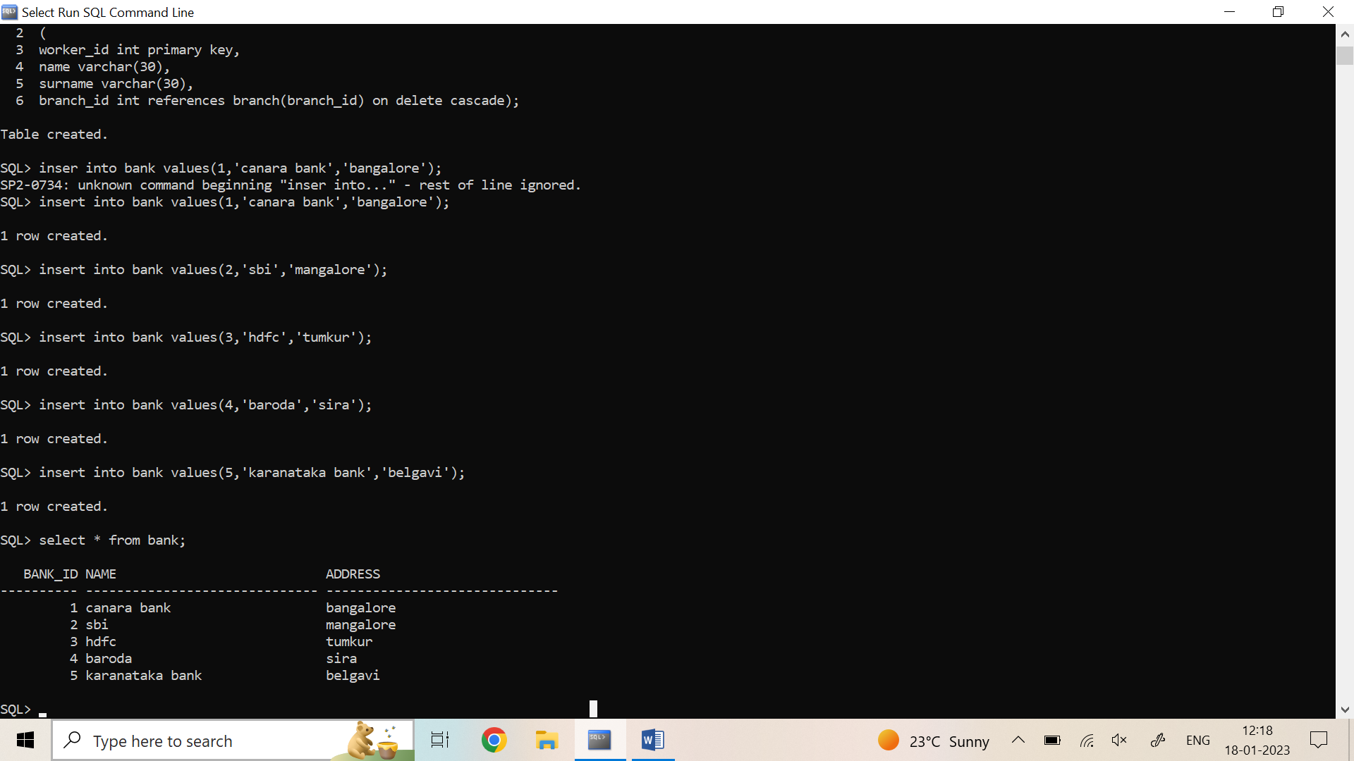

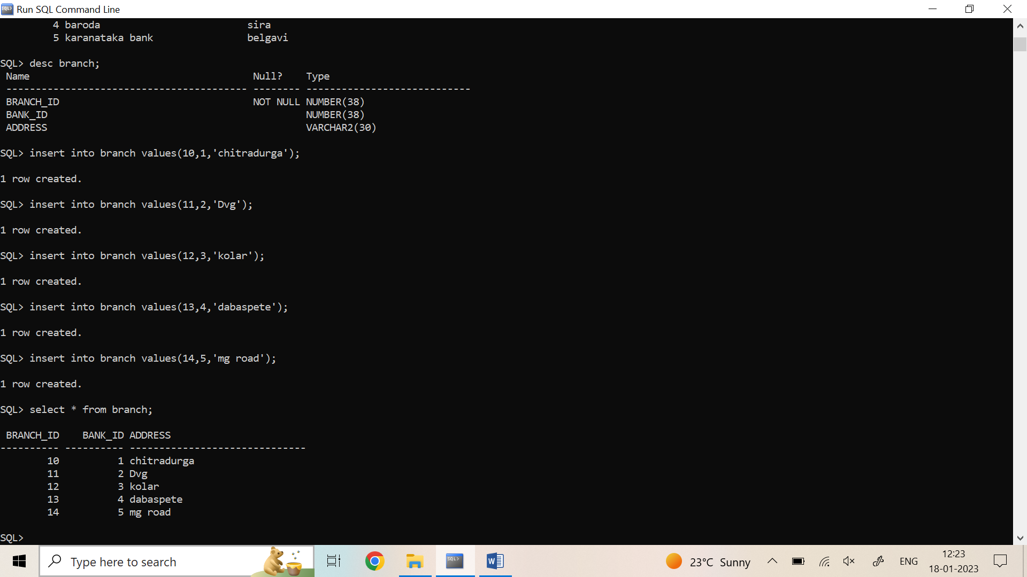

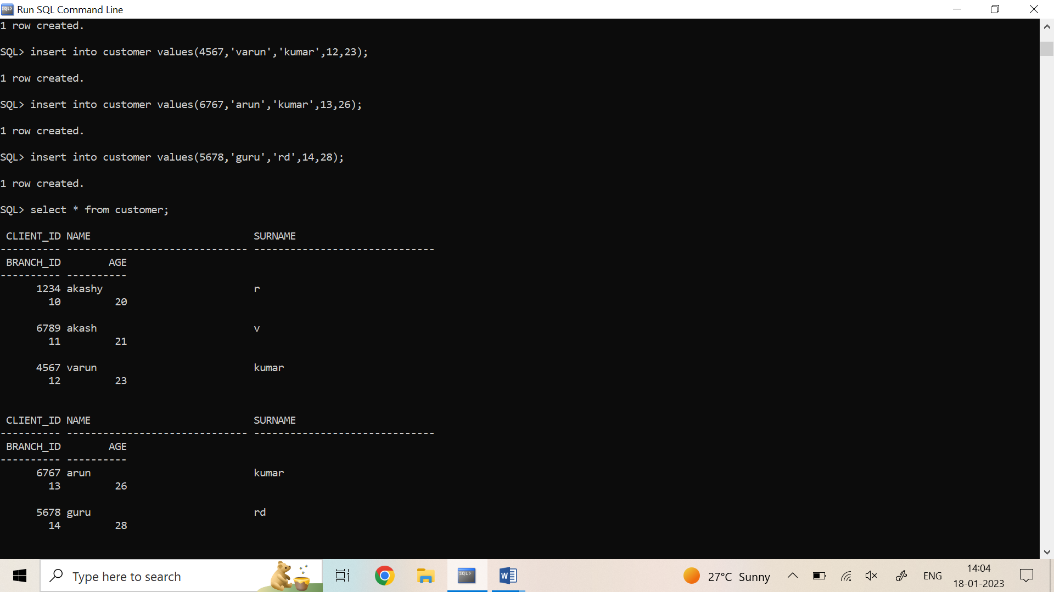

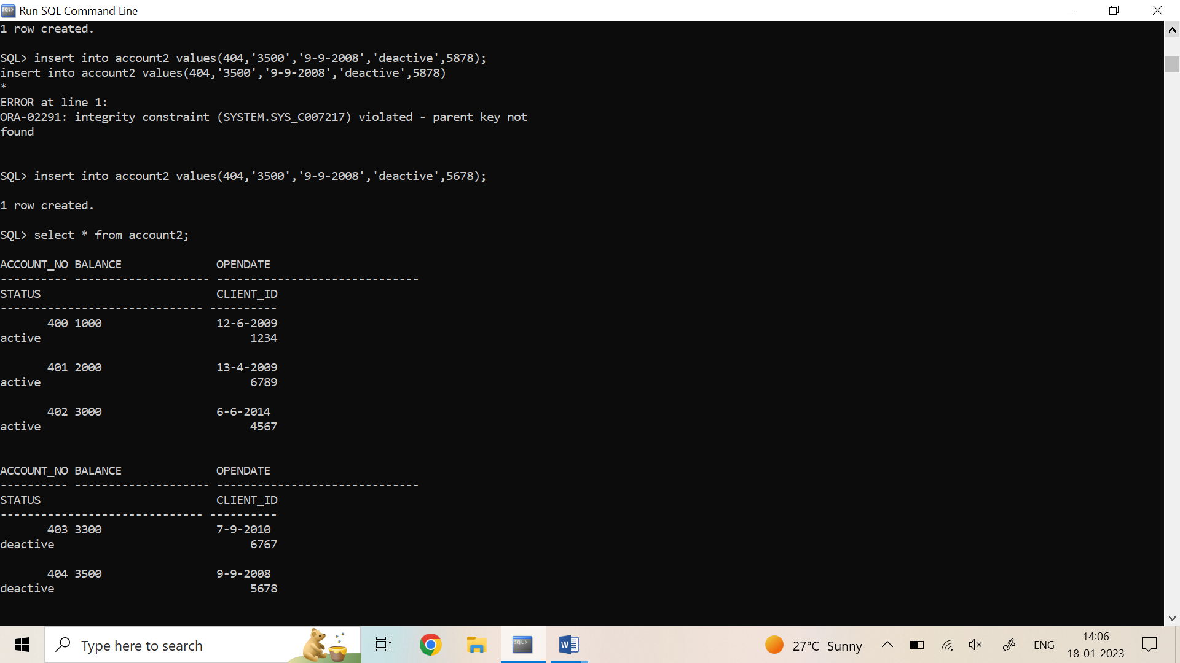

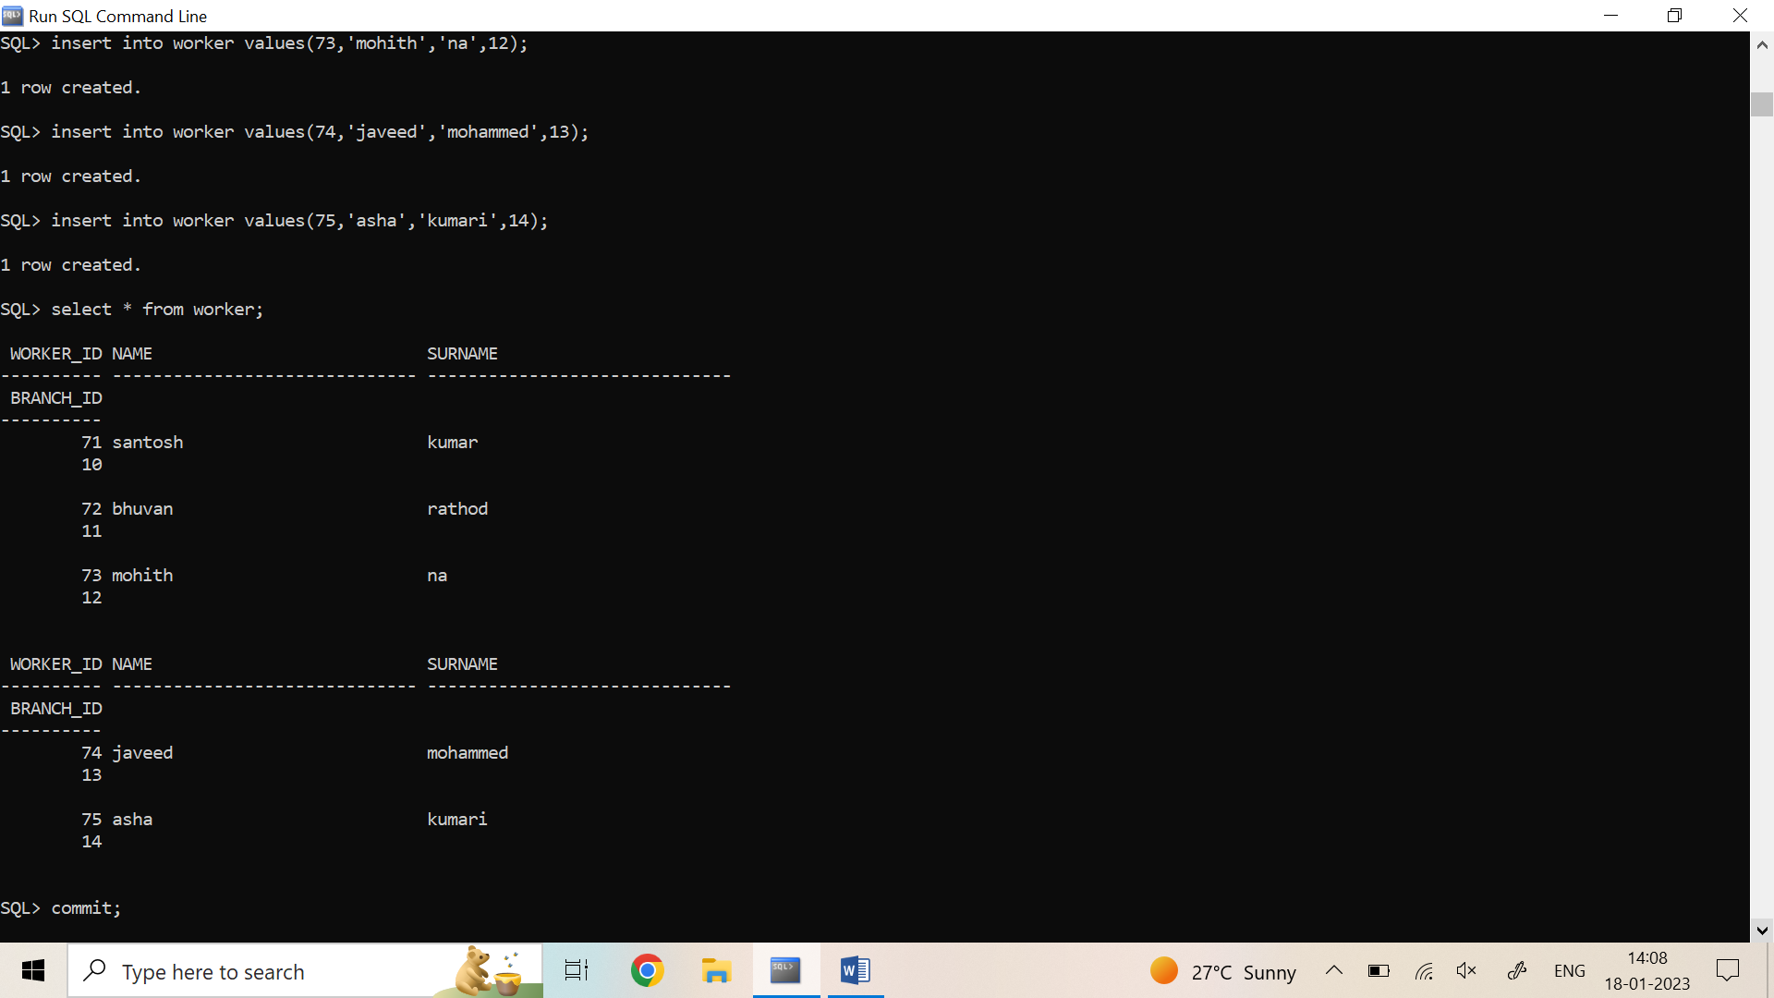

**Queries**

* **Write query to display account_id, name whose account are active**

select a.account_no,

c.name from account2 a,customer c

where a.client_id=c.client_id

and a.status='active';

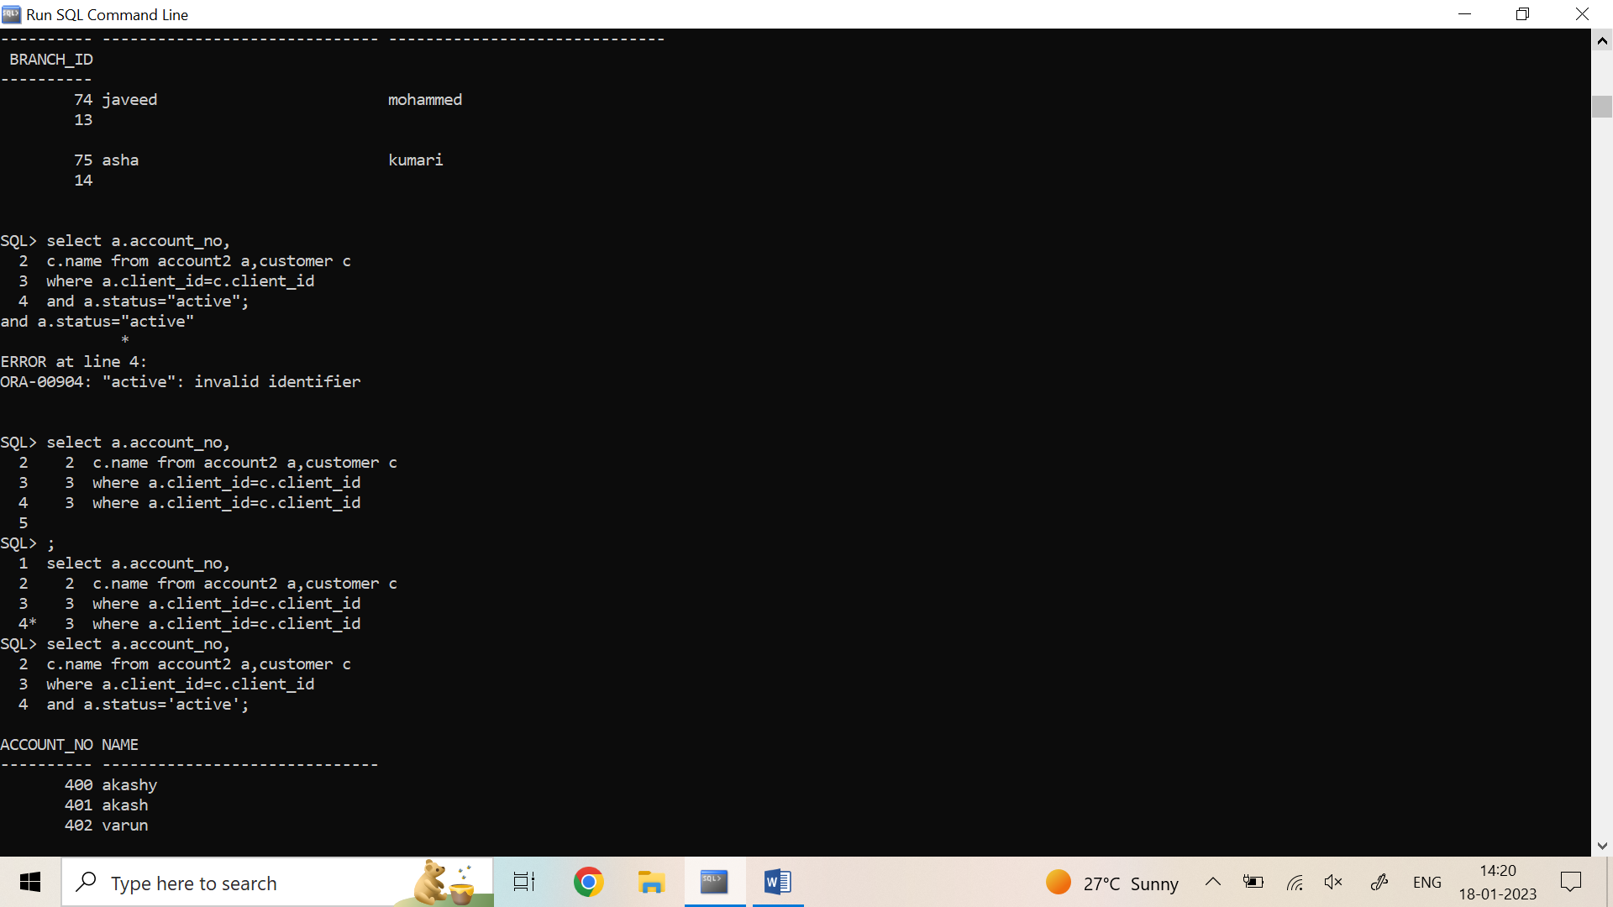

* **Let the customer who’s balance is more than 2000**

select c.name

from account2 a,customer c

where a.client_id=c.client_id

and balance >2000;

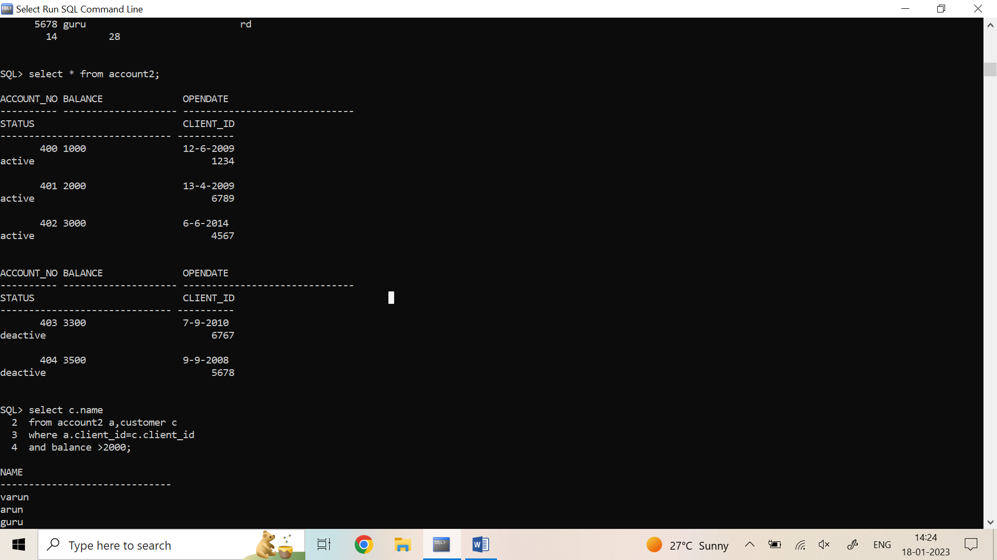

* **List the worker who is working in kolar branch**

select w.name

from worker w,branch b

where b.branch_id=w.branch_id

and address='kolar';

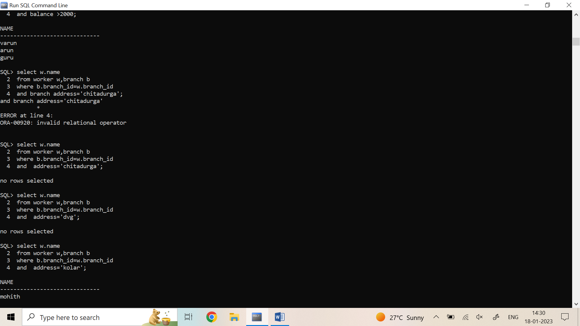

* **Number of branches to a particular branch**

select count(*) no_of_branches

from bank b,branch br

where b.bank_id=br.branch_id;

